Shrawani shinde

2213180

# ASSIGNMENT NO: 2

**AIM : Data Definition Commands for creating database and tables (relations)**

**Create a Table for Manufacturing industry / Hospital/ Company with min 5 columns add primary key.**

**Alter any one column from the above table.**

**Rename two columns from the above table**

**Truncate the table**

**Drop the table.**

**INDEX TERMS**: DDL,DML, PL/SQL Stored Procedure, functions

**THEORY**

**Different types of commands in SQL:**

1. DDL commands: - To create a database objects
2. DML commands: - To manipulate data of a database objects. C). DQL command: - To retrieve the data from a database.

D). DCL command - To control the data of a database.

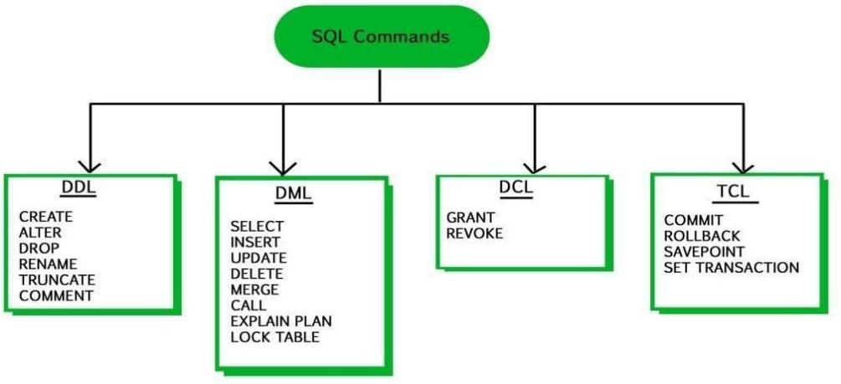

**DDL commands:**

The DDL part of SQL permits database tables to be created or deleted. It also define

indexes (keys), specify links between tables, and impose constraints between tables. The schema for each relation. The domain of values associated with each attribute. Integrity constraints And as we will see later, also other information such as The set of indices to be maintained for each relations.

These commands are:

–**CREATE**: to create a new data structure.

–**ALTER**: to change an existing data structure.

–**DROP**: to remove an entire data structure.

–**TRUNCATE** : to remove all rows from the table.

–**RENAME** : to rename existing table

**Data Manipulation Language**

The Data Manipulation Language (DML) is used to insert and modify database information. Different DML statements includes:

–INSERT: to add records into the table

–UPDATE: to change column value in the table

–DELETE: to remove rows from the table

**Create Table**

create table *student* (

*ID* varchar(5), *name* varchar(20) not null, *dept_name* varchar(20), *tot_cred* numeric(3,0), primary key *(ID),* foreign key *(dept_name*) references *department*);

**Insert**

insert into *instructor* values (‘10211’, ’Smith’, ’Biology’, 66000);

**Delete**

Remove all tuples from the *student* relation : delete from *student;*

**Select Operation**

List in alphabetic order the names of all instructors

select distinct *name* from *instructor* order by *name;*

**Aggregate Functions**

# Nested Sub Query

Definition of Nested Subquery:-

A Subquery or Inner query or Nested query is a query within another SQL query and embedded within the WHERE clause. A subquery is used to return data that will be used in the main query as a condition to further restrict the data to be retrieved. Subqueries can be used with the SELECT, INSERT, UPDATE, and DELETE statements along with the operators like =, <, >, >=, <=, IN, BETWEEN etc.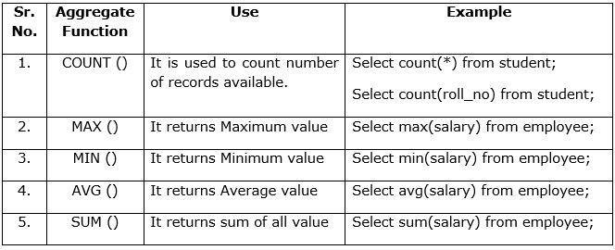

A subquery can be nested inside other subqueries. SQL has an ability to nest queries within one another. A subquery is a SELECT statement that is nested within another SELECT statement and which return intermediate results. SQL executes innermost subquery first, then next level.

**Sub queries with the SELECT Statement:**

Sub queries are most frequently used with the SELECT statement. The basic syntax is as follows: SELECT column_name [, column_name ]

FROM table1 [, table2]

WHERE column_name OPERATOR (SELECT column_name [, column_name ] FROM table1 [, table2]

[WHERE])

**Example of IN Operator**

Consider the CUSTOMERS table having the following records:

+ + + + + +

| ID | NAME | AGE | ADDRESS | SALARY |

+ + + + + +

| 1 | Ramesh | 35 | Ahmedabad | 2000.00 |

| 2 | Khilan | 25 | Delhi | 1500.00 |

| 3 | kaushik | 23 | Kota | 2000.00 |

| 4 | Chaitali | 25 | Mumbai | 6500.00 |

| 5 | Hardik | 27 | Bhopal | 8500.00 |

| 6 | Komal | 22 | MP | 4500.00 |

| 7 | Muffy | 24 | Indore | 10000.00 |

+ + + + + +

Now, let us check following sub query with SELECT statement:

SELECT * FROM CUSTOMERS WHERE ID IN (SELECT ID FROM CUSTOMERS WHERE SALARY > 4500);

This would produce the following result

+ + + + +

| ID | NAME | AGE | ADDRESS | SALARY |

+ + + + + +

| 4 | Chaitali | 25 | Mumbai | 6500.00 |

| 5 | Hardik | 27 | Bhopal | 8500.00 |

| 7 | Muffy | 24 | Indore | 10000.00 |

+ + + + + +

**Example of NOT IN Operator**

Now, let us check following sub query with SELECT statement:

SELECT * FROM CUSTOMERS WHERE ID NOT IN (SELECT ID FROM CUSTOMERS WHERE SALARY > 4500);

This would produce the following result

+ + + + + +

| ID | NAME | AGE | ADDRESS | SALARY |

+ + + + + +

| 1 | Ramesh | 35 | Ahmedabad | 2000.00 |

| 2 | Khilan | 25 | Delhi | 1500.00 |

| 3 | kaushik | 23 | Kota | 2000.00 |

| 6 | Komal | 22 | MP | 4500.00 |

|+ + + + + +

# Joins:

The SQL Joins clause is used to combine records from two or more tables in a database. A JOIN is a means for combining fields from two tables by using values common to each. Several operators can be used to join tables, such as =, <, >, <>, <=, >=, !=, BETWEEN, LIKE, and NOT; they can all be used to join tables. However, the most common operator is the equal to symbol. There are different types of joins available in SQL

# Inner Join:

The most important and frequently used of the joins is the INNER JOIN. They are also referred to as an EQUIJOIN. The INNER JOIN creates a new result table by combining column values of two tables (table1 and table2) based upon the join-predicate. The query compares each row of table1 with each row of table2 to find all pairs of rows which satisfy the join-predicate. When the join predicate is satisfied, column values for each matched pair of rows of A and B are combined into a result row.

Syntax: SELECTtable1.column1, table2.column2...FROM table1INNER JOIN table2 ONtable1.common_field=table2.common_field;

# Left Join

The SQL LEFT JOIN returns all rows from the left table, even if there are no matches in the right table. This means that if the ON clause matches 0 (zero) records in the right table; the join will still return a row in the result, but with NULL in each column from the right table. This means that a left join returns all the values from the left table, plus matched values from the right table or NULL in case of no matching join predicate.

Syntax: SELECTtable1.column1, table2.column2...FROM table1LEFTJOINtable2 ONtable1.common_field=table2.common_field;

# Right Join:

The SQL RIGHT JOIN returns all rows from the right table, even if there are no matches in the left table. This means that if the ON clause matches 0 (zero) records in the left table; the join will still return a row in the result, but with NULL in each column from the left table. This means that

a right join returns all the values from the right table, plus matched values from the left table or NULL in case of no matching join predicate.

Syntax: SELECT table1.column1, table2.column2...FROM table1 RIGHTJOIN table2 ONtable1.common_field=table2.common_field;

# Full Join:

The SQL FULL JOIN combines the results of both left and right outer joins. The joined table will contain all records from both the tables and fill in NULLs for missing matches on either side. MySQL does not support full join so we have to use the set operation ‘Union All’ for left outer join and the right outer join on those two tables. Syntax: <Left Outer Join Query> Union All <Right Outer Join Query> e)Self Join: The SQL SELF JOIN is used to join a table to itself as if the table were two tables; temporarily renaming at least one table in the SQL statement. Here, the WHERE clause could be any given expression based on your requirement.

Syntax: SELECT a.column_name, b.column_name... FROM table1a, table1b WHERE a.common_field = b.common_field;

# Cartesian or Cross Join:

The CARTESIAN JOIN or CROSS JOIN returns the Cartesian product of the sets of records from two or more joined tables. Thus, it equates to an inner join where the join-condition always evaluates to either True or where the join-condition is absent from the statement. Syntax:SELECTtable1.column1, table2.column2...FROM table1,table2[, table3]

# PL/SQL provides two kinds of subprograms−

Functions− These subprograms return a single value; mainly used to compute and return a value. Procedures−These subprograms do not return a value directly; mainly used to perform an action. **Creating a Procedure:**

A procedure is created with the CREATE OR REPLACE PROCEDURE statement.

CREATE [ OR REPLACE] PROCEDURE procedure_name [(parameter_name [IN | OUT| INOUT] type[, ...])]

{IS |AS}

BEGIN <procedure_body> END procedure_name;

Where, procedure-name specifies the name of the procedure. [OR REPLACE]option allows the modification of an existing procedure. The optional parameter list contains name, mode and types of the parameters. IN represents the value that will be passed from outside and OUT represents the parameter that will be used to return a value out side of the procedure. Procedure-body contains the executable part. The AS keyword is used instead of the IS keyword for creating a stand alone procedure.

Executing a Standalone Procedure A stand alone procedure can be called in two ways

* 1. Using the EXECUTE keyword
  2. Calling the name of the procedure from a PL/SQL block

**Function :** A function is same as a procedure except that it returns a value.

# Creating a Function

A standalone function is created using the CREATE FUNCTION statement. The simplified syntax for the CREATE OR REPLACE PROCEDURE statement is as follows :

CREATE [OR REPLACE] FUNCTION function_name [(parameter_name [IN|OUT |INOUT] type[, ...])] RETURN return_datatype {IS |AS}

BEGIN <function_body> END [function_name];

Where, function-name specifies the name of the function. [OR REPLACE] option allows the modification of an existing function. The function must contain are turn statement. The RETURN clause specifies the data type you are going to return from the function. Function-body contains the executable part. The AS keyword is used instead of the IS keyword for creating a standalone function. Calling a Function While creating a function, you give a definition of what the function has to do. To use a function, you will have to call that function to perform the defined task. When a program calls a function, the program control is transferred to the called function. A called function performs the defined task and when its return statement is executed or when the last end statement is reached, it returns the program control back to the main program.

**Screenshots :**

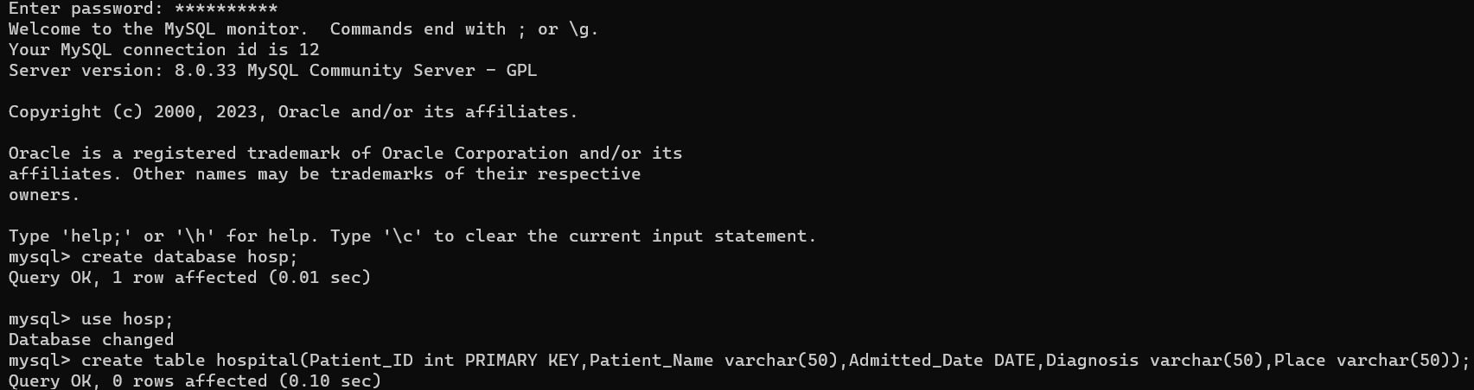

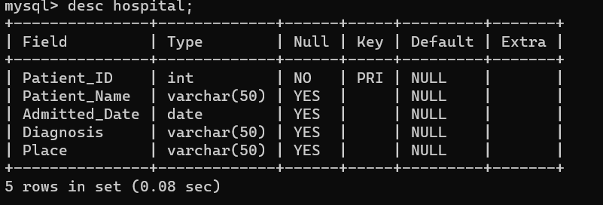

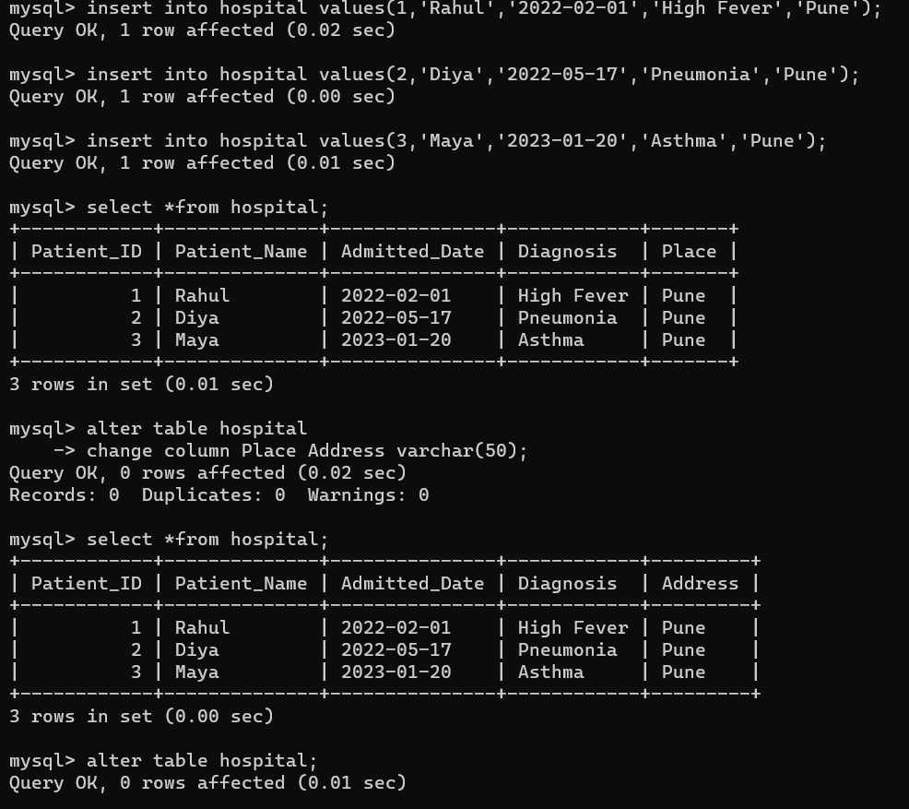

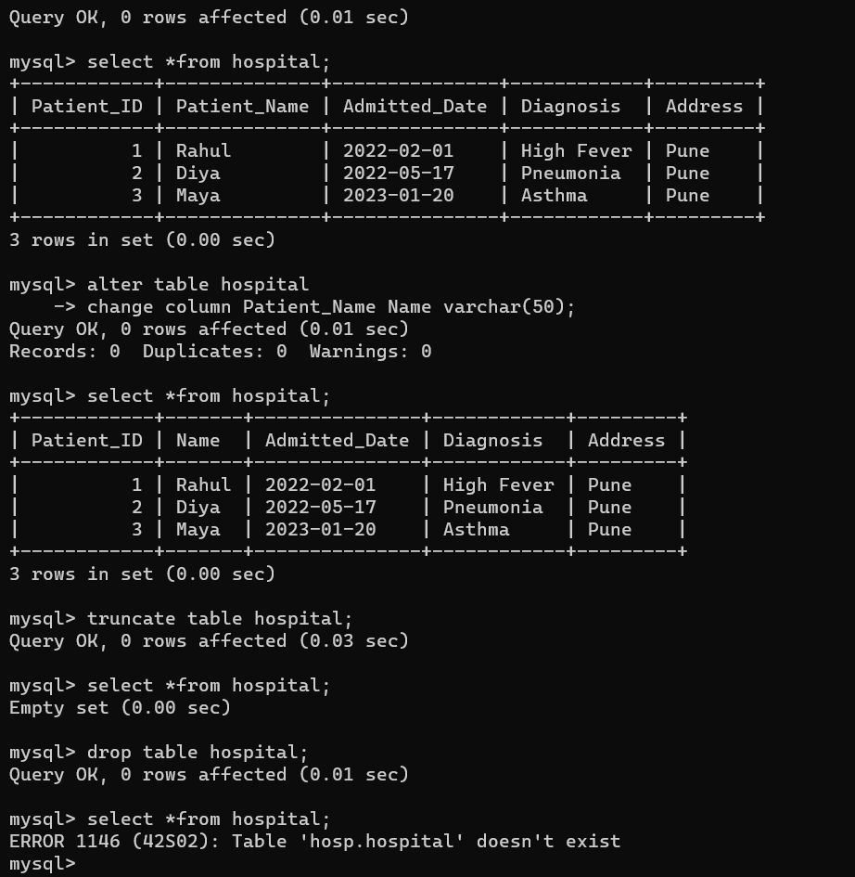

# Exercise :

Evaluate query for following questions and perform operations **Classicmodels** database. 1)Report those payments greater than 100000;

2)Report total payments for october 28,2004; 3)What is the minimum payment received?

4)How many employees are there in the company? 5)List the product lines that contain 'Cars'

6)How many products in each product line? (stored procedure) 7)What are the names of executives with VP or Manager in their title? 8)What is the average percentage markup of the MSRP on buyPrice?

9)Which orders have a value greater than $5000? 10)List the value of 'On Hold' orders

11)Report the number of orders 'On Hold' for each customer. 12)Who are the employees in Boston?

1. Report the products that have not been sold
2. Compute the commission for each sales representative , assuming the commision is 5% of the value of an order.sort by employee last name and first name

# FAQs:

1. What do you understand by a subquery? When is it used?

Ans: A Subquery can be simply defined as a query within another query. Using subquery we can retrieve data from one table based on the results of another query. Subqueries can be used in various parts of a SQL statement, such as SELECT, FROM, WHERE, and HAVING clauses.

1. What is difference between FUNCTION and PROCEDURE in PL/SQL?

Ans:

|  |  |
| --- | --- |
| Function | Procedure |
| 1.A function is used to calculate result using given inputs. | 1.A procedure is used to perform certain task in order. |
| 2.A function can be called by procedure | 2.A procedure cannot be called by function. |
| 3.A function can be called within a query. | 3. A procedure cannot be called within a query. |
| 4.Whenever a function is called, it is first compiled before being called. | 4.A procedure is compiled once and can be called multiple times without being compiled. |
| 5.Functions always return a value after the execution of queries. | 5.The procedure can return a value using “IN OUT” and “OUT” arguments. |

1. What is the difference between cross joins and natural joins?

Ans:

|  |  |
| --- | --- |
| Cross Joins | Natural Joins |
| 1.A cross join, also known as a Cartesian join, returns the Cartesian product of the two sets of records being joined. | 1.A natural join is a type of join that automatically matches columns with the same name in both tables and returns rows where the values in these columns are equal. |
| 2.Cross Join will produce cross or cartesian product of two tables . | 2.Natural Join joins two tables based on same attribute name and datatypes. |
| 3.It id defined using ‘CROSS JOIN’ keyword. | 3.It is defined using ‘NATURAL JOIN’ keyword |
| 4.In Cross Join, If there is no condition specifies then it returns all possible pairing of rows from both the tables whether they are matched or unmatched. | 4.In Natural Join, If there is no condition specifies then it returns the rows based on the common column. |
| 1. Syntax : SELECT * FROM table1 NATURAL JOIN table2; | 4.Syntax:SELECT * FROM table1 CROSS JOIN table2; |

# Conclusion:

Out come of the experiment is understanding of

1. Implement DDL,DML Statements, aggregate functions, all types of Joins.
2. Implement Sub-Queries, PLSQL Stored procedure & Functions